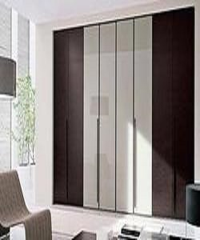

Latest design cupboard

$250.38

Availability: In stock

Description

Brown and grey Double Door Cupboard. To ensure a defect free range, these wardrobes undergo different predefined quality assurance tests by our team of quality controllers. Maple solid wood Available with us at highly affordable market prices, these wardrobes are available in customers stated specifications.